Overview of Application Virtualization (Explanation)
Application Virtualization is a technique that allows software applications to run in an isolated environment, independent of the underlying operating system. Instead of being installed directly on the OS, the application is packaged in a virtual container that includes all the necessary files, libraries, and settings it needs to function.
This approach eliminates common problems like DLL conflicts, registry issues, or application compatibility errors. It also makes applications more portable, meaning the same virtualized app can run on multiple devices without reinstallation.
For organizations, Application Virtualization is very useful because it supports centralized deployment and management. IT administrators can deliver applications to multiple users from a central server, saving time and reducing maintenance work.
In short, Application Virtualization makes applications easier to deploy, manage, and run across different environments while reducing compatibility issues.
Benefits of Application Virtualization
- Centralized Deployment & Management – Applications can be packaged once and deployed to multiple systems, reducing installation time.
- Reduced Software Conflicts – Since applications run in isolated containers, they do not interfere with each other or the operating system.
- Cost and Time Efficiency – Updates and patches can be rolled out centrally, saving effort and reducing downtime.
- Flexibility & Portability – Applications can be accessed from different devices and environments without reinstallation.
- Improved Security – Applications run in a controlled environment, which minimizes risks of system corruption.
Limitations of Application Virtualization
- Not Suitable for All Applications – Some apps that need deep integration with hardware or the OS may not work properly.
- Performance Overhead – In certain cases, running apps in a virtual environment may reduce speed compared to native installation.
- Licensing and Infrastructure Costs – Requires investment in virtualization software and server infrastructure.
- Learning Curve – IT teams may need training to manage and troubleshoot virtualized applications.
Comparison with Other Technologies
- Traditional Installation – Apps are installed directly on the OS, leading to higher chances of conflicts.
- Virtual Machines (VMs) – Virtualizes the entire operating system and hardware, which consumes more resources compared to application virtualization.
- Containers (e.g., Docker) – Isolate apps at the OS level, faster and lightweight, but serve a slightly different use case (mostly for developers and cloud environments).
- Application Virtualization – Focuses only on the application layer, making it lightweight and easier for enterprises to manage software.
Common Platforms for Application Virtualization
Several well-known platforms provide application virtualization solutions. Each has its own approach and strengths:
Microsoft App-V (Application Virtualization)
- One of the most widely used enterprise solutions.
- Applications are packaged and streamed from a central server to client computers.
- Users can start using the app even before the full package is downloaded.
- Provides strong integration with Windows environments and Active Directory.
- Commonly used in corporate IT environments for centralized control.
VMware ThinApp
- Focuses on creating portable applications that can run without installation.
- Applications are packaged into a single executable file.
- No need for administrative rights on the client machine.
- Ideal for testing, troubleshooting, or carrying applications on external drives.
- Strong isolation prevents registry or file conflicts.
Citrix App Layering
- Works by separating applications and operating systems into layers.
- Each layer can be updated or modified independently.
- Makes it easy to deliver apps across virtual desktops and servers.
- Supports integration with Citrix Virtual Apps and Desktops.
- Reduces management complexity in large organizations.
Summary:
- App-V is best for Windows enterprise environments.
- ThinApp is best for portability and lightweight deployment.
- Citrix App Layering is best for layered management in virtual desktop infrastructures (VDI).

Architecture and Key Components of Application Virtualization
Application Virtualization works through a set of components that manage how apps are packaged, delivered, and run on client systems. The architecture may differ slightly across platforms, but the core idea remains similar.
Key Components
Management/Server Console
- Central control system used by IT administrators.
- Responsible for packaging, publishing, and delivering applications to users.
- Provides policy-based access (who gets which application).
Client Agent (Runtime Environment)
- Installed on user machines to run virtualized applications.
- Creates the virtual environment where the application operates.
- Ensures apps run smoothly without directly interacting with the OS.
Packaging/Sequencing Tools
- Used to prepare or “virtualize” an application.
- Captures the application’s files, registry entries, and dependencies.
- Packages them into a single virtual application file or layer.
Streaming/Delivery Mechanism
- Allows apps to be streamed from the server to clients.
- Users can start using apps even before they are fully downloaded.
- Ensures faster delivery and updates.
Isolation Layer
- The heart of application virtualization.
- Keeps applications separated from the OS and other apps.
- Prevents conflicts, such as registry or DLL version issues.
Summary:
- Server/Management Console → Publishes apps.
- Client Agent → Runs apps in a virtual environment.
- Packaging Tools → Create virtual apps.
- Streaming → Delivers apps efficiently.
- Isolation Layer → Prevents conflicts.

Creating virtual machine of windows 10

Step 1: Download the Necessary Components
- Download VirtualBox: First, you need to install VirtualBox on your computer. You can download it from the official VirtualBox website.
- Download the Windows 10 ISO File: You will need the Windows 10 ISO file. This is a single file that contains the entire Windows 10 operating system. You can download it from Microsoft's official website. Using the Microsoft Media Creation Tool is the easiest way to get the ISO file.

Step 2: Create a New Virtual Machine in VirtualBox
- Open VirtualBox: Launch the VirtualBox application.
- Click the 'New' Button: In the top menu, click the 'New' button. This will open a new wizard.
- Name the VM and Choose the OS:
  - Name: Give your virtual machine a name, such as "My Windows 10 VM".
  - Folder: Choose the folder where you want to save the virtual machine's files.
  - ISO Image: Now, select the Windows 10 ISO file you downloaded earlier.
  - Type & Version: For Type, select Microsoft Windows, and for Version, select Windows 10 (64-bit) (if your ISO is 64-bit).

- Set Hardware Specifications:
  - Base Memory (RAM): Allocate RAM for your virtual machine. Windows 10 needs at least 4 GB (4096 MB) of RAM. If your host computer has more RAM, providing 8 GB or more is better.
  - Processors (CPU): Decide how many CPU cores to assign to the virtual machine. Choose at least 2 CPUs.

- Create a Virtual Hard Disk:
  - Disk Size: Decide the size of the virtual hard disk. A minimum of 50 GB is required for Windows 10, but providing 80 GB or 100 GB is better for future use. Leave the 'Pre-allocate Full Size' option unchecked so the disk can expand dynamically.

- Summary: A summary will appear. If everything looks correct, click 'Finish'.
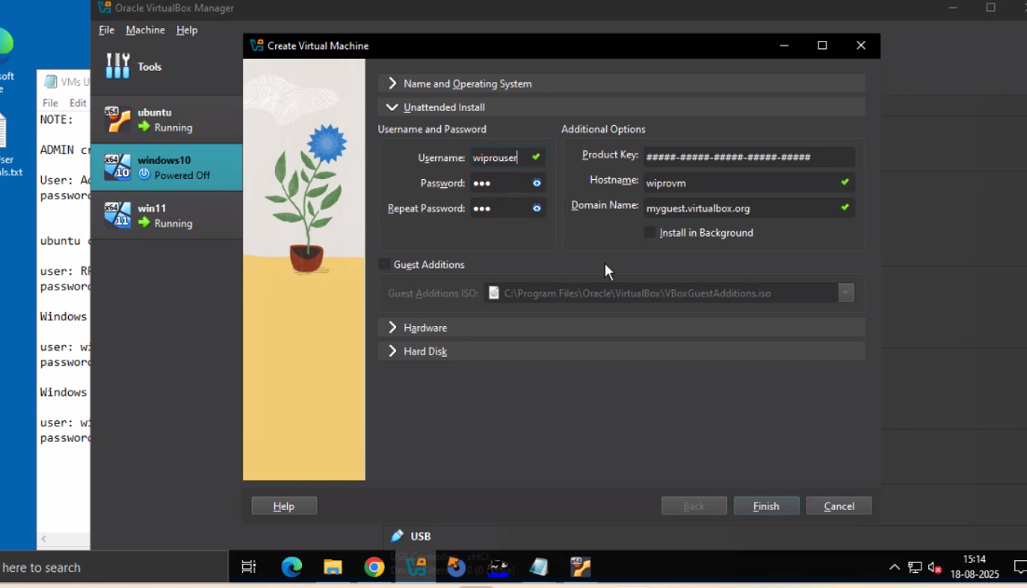
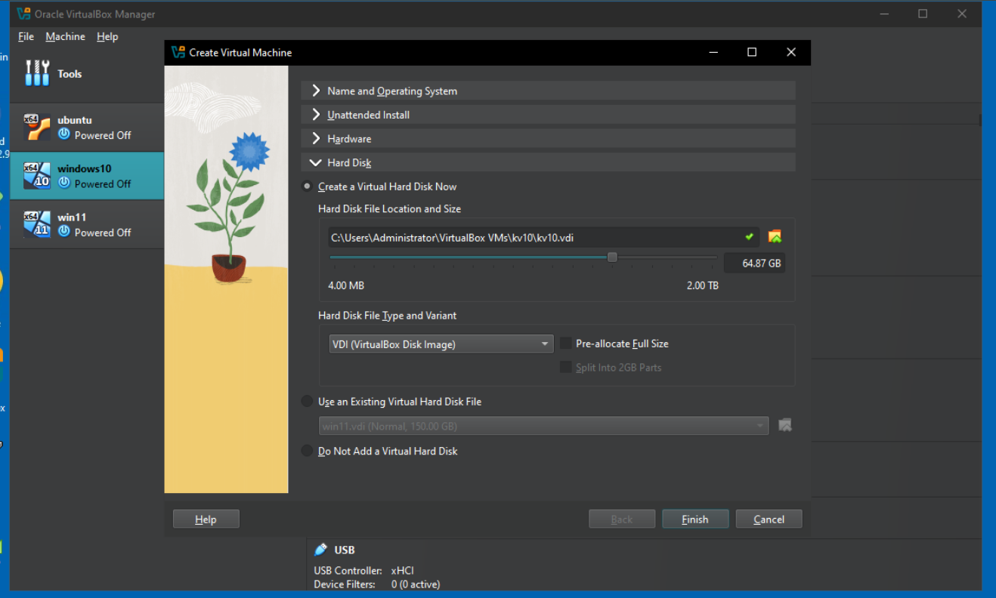

Step 3: Install Windows 10
- Start the Virtual Machine: Your new virtual machine will appear in the list. Select it and click the 'Start' button.
- Begin Windows Setup: When the virtual machine starts, it will automatically boot into the Windows 10 installer.
- Complete the Setup:
  - Language, Time, and Keyboard: Choose your preferred settings.
  - Click 'Install now'.
  - Product Key: If you have a product key, enter it. If not, click 'I don't have a product key'.
  - Edition: Choose the Windows 10 edition you want to install, such as Home or Pro.
  - Terms of Agreement: Accept the terms.
  - Installation Type: Choose 'Custom: Install Windows only'.
  - Disk Selection: You will see unallocated space. Select it and click 'Next'.
- Installation: The Windows 10 files will begin to install. This process will take some time, and the virtual machine will reboot several times.
- Initial Setup: After the installation, the initial Windows 10 setup will start, where you can configure your user account, password, and privacy settings.
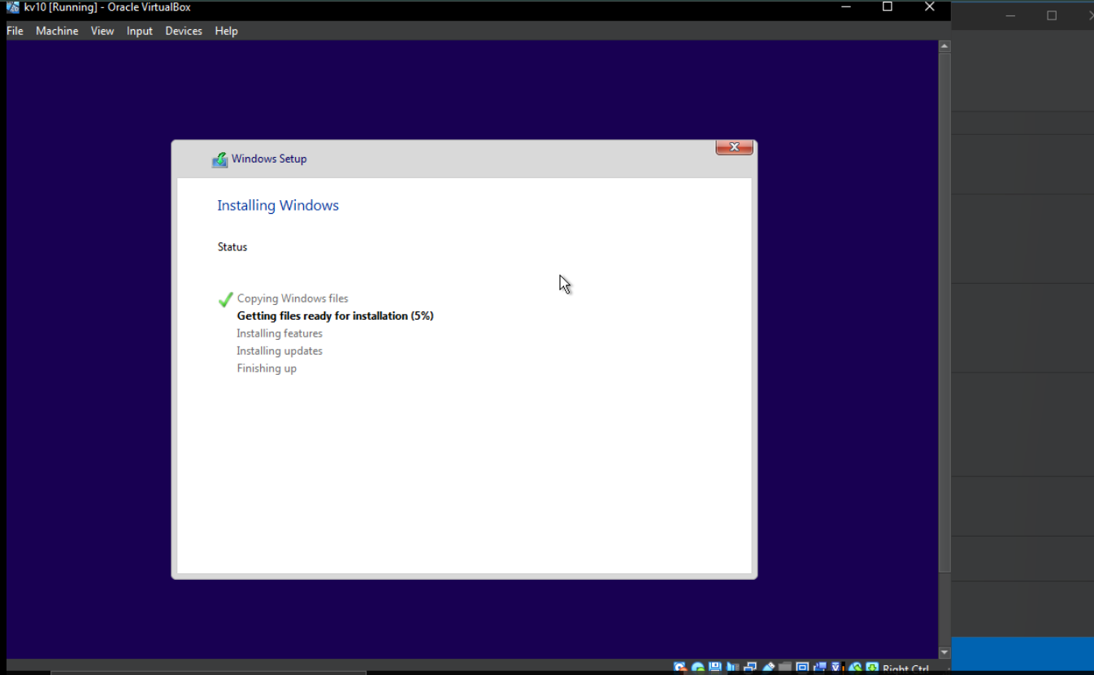
Step 4: Install Guest Additions (Optional, but Recommended)
After installing Windows 10, the screen may be small or the mouse may not work smoothly. To fix this, install Guest Additions:
- With the virtual machine running, click on 'Devices' in the VirtualBox window's menu bar.
- Select 'Insert Guest Additions CD Image'.
- Inside the virtual machine, go to 'This PC' and open the VirtualBox Guest Additions drive.
- Run the installer file for your system (e.g., VBoxWindowsAdditions-x64.exe) and follow the instructions.
- After the installation is complete, restart the virtual machine. The screen resolution and mouse movement will now be smooth.
Our Windows 10 virtual machine is now ready to use!
